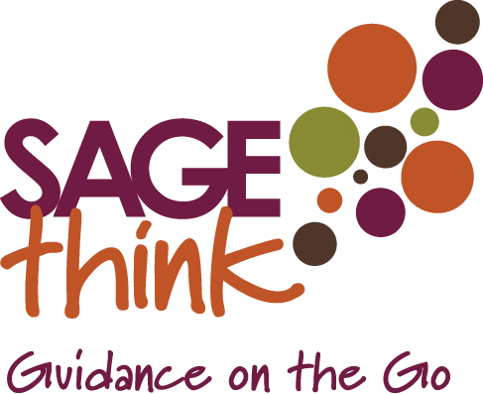
“What's done, is done”
~ William Shakespeare, Macbeth
"The best way to predict the future is to create it."
~ Peter Drucke
Designing the New Year
- What are you committed to accomplishing in the New Year?
Look at all the areas of your life. Include specific results as well as areas you would like to expand which are not necessarily measurable.
Areas to consider as you answer the question:
Personal Growth

Family and Friends

Significant Other and Romance

Professional Development

Health and Well-being

Spiritual Enrichment

Your Home, Office, and Physical Environment

Leadership and Management in your Organization

Fun, Recreation, Travel, and Hobbies

- Separate from your goals and accomplishments, are there areas that you would like to learn about, study or explore in the New Year? If so, what are they?

- Are there relationships in your life that you want to create, develop or enhance? If so, who are they?

- What “limiting thoughts or beliefs” could stop you from accomplishing what you are out to accomplish in the New Year?
Ask yourself the question: “What is holding me back?”

- In order to accomplish your goals or realize your intentions for the New Year, what new beliefs will you need to adopt and live from?

- In order to accomplish your goals or realize your intentions for the New Year, what skills, behaviors or new habits will you need to develop?

- In order to accomplish your goals or realize your intentions for the New Year, what support structures will you need?

- If you were going to design a headline or theme for the New Year, what would it be?

- Is there anything else you would like to target, design or create in 2017?

